**Inbreeding and sex allocation in hermaphroditic metapopulations**

Camille Roux, Charles Mullon, Samuel Neuenschwander, Jérôme Goudet, John R. Pannell1

Department of Ecology and Evolution

Biophore Building

University of Lausanne

1015 Lausanne

Switzerland

email: john.pannell@unil.ch

KEY WORDS:

SHORT TITLE:

**Introduction**

‘Sex allocation’ refers to the proportion of reproductive resources an individual invests in its male versus female sexual functions. In dioecious or gonochoristic species, it is synonymous with the sex ratio of sons and daughters produces by mothers, weighted by the relative cost of raising an offspring of sex to independence. For a long time, the fact that many species appeared to produce equal sex ratios was an evolutionary puzzle, as males might seem to be a wasted resource from the perspective of the potential intrinsic growth of a population. Although the German biologist Karl Düsing {, 1884 #5061} first provided an evolutionary explanation for equal sex ratios, the idea is often credited to Ronald Fisher {, 1930 #275}. Simply put, because autosomal genes have an equal chance of passing to the next generation through male and female gametes, selection should favour investment in the success of each of these two paths. The corollary is that, in populations with an unequal sex ratio, selection will favour alleles in the minority sex, because they must, on average, leave more progeny than those in the majority sex. In such populations, natural selection should thus rapidly bring about an equilibration of the sex ratio.

Although equal sex ratios are common, many species produce female-biased sex ratios, with more daughters than sons. William D. Hamilton {, 1967 #349} explained these ‘extraordinary sex ratios’ largely in terms of the effects of ‘local mate competition’, which violates the assumption of random mating made by Düsing and Fischer. If mating is not random, and, in particular, if sons must compete among themselves for mating with a restricted number of females, selection will favour a strategy that biases the sex ratio towards the production of fewer sons and more daughters. Hamilton’s {, 1967 #349} explanation is supported by a wide range of empirical observations, and indeed stands as perhaps the most successful cornerstone of life-history theory (REFS). It is particularly well illustrated by examples where the sons and daughters of a small number of fertilized females hatch together and mate before dispersing; when the number of mothers is small, the chance of mating between full or half siblings (inbreeding) is high. Indeed, the inbreeding coefficient, which measures the degree to which related individuals mate with one another relative to the case of random mating across the population, is a reliable predictor of sex ratio chosen by mothers for their progeny.

While the above ideas were developed principally with gonochoristic species in mind and have found substantial support from studies of species with separate sexes, they also apply to hermaphrodites. Hermaphrodites do not generally produce sons or daughters, but their sex allocation can be viewed in terms of the relative investment they make to their male versus female functions, e.g., to sperms versus eggs or, for plants, to pollen versus seeds – even though these relative investments may be difficult to compare directly (see Discussion). Just as for species with separate sexes and sex ratios, selection on the sex allocation of hermaphrodites should favour equal investment in both sexual functions if mating is random and both pollen and seeds are widely dispersed. (Although it is often supposed that hermaphroditic plants invest more heavily in their female function, which involves both flower, seed and fruit production, measures of the cost of male investment in terms of trade-offs with growth show that it, too, can be high and can equal or even surpass the costs of female function; {Harris, 2008 #5607}.) Similarly, in hermaphroditic populations subject to local mate competition, we should expect individuals to bias their sex allocation to their female function. Thus, female-biased allocation is predicted for plants where pollen is dispersed to limited number of receptive flowers (over small distances) than seeds {Lloyd, 1982 #523}. Similarly, female-biased allocation is predicted for partially inbreeding hermaphroditic populations, whether through self-fertilization or biparental reproduction.

The expected female-biased sex allocation of inbreeding hermaphrodites is well supported by empirical data, particularly comparisons between populations or species that have different rates of self-fertilization. For instance, plant populations that have undergone a transition from outcrossing to selfing often quickly evolve a ‘selfing syndrome’, which includes reduced allocation to pollen and traits that play a role in pollen dispersal {Lemen, 1980 #490} REFS. Although this has been attributed to the ‘greater efficiency’ of self-fertilizing plants {Cruden, 1977 #197}, their reduced allocation to male function is better seen as an illuminating example of selection under local mate competition (or ‘local sperm competition; {Schärer, 2009 #5724; Scharer, 2013 #6593}, where pollen grains (or sperm) from the same individual compete to fertilize its own restricted pool of ovules (or eggs).

Self-fertilization represents the most extreme form of inbreeding, but strong population structure can also bring about inbreeding. In demographically stable plant populations in which seeds and pollen are dispersed over short distances, mating partners will often be more closely related than individuals drawn randomly from the population, but the levels of inbreeding brought about by such population viscosity are relatively mild compared with self-fertilization. By contrast, we might expect species subject to metapopulation dynamics, i.e., frequent local extinctions and recolonisations, to show high levels of inbreeding, too. For instance, populations founded by single self-fertile individuals may grow to large local sizes over the course of a few generations by self-fertilization. Even if mating is random within such (potentially large) populations, all individuals will be closely related through their descent from a single recent coloniser, and we should expect the inbreeding that results from such metapopulation dynamics to influence selection on the sex allocation. In particular, we should expect metapopulation dynamics to bring about selection for female-biased sex allocation in hermaphroditic species. To our knowledge, this prediction has not yet been examined in any detail. How rapid must population turnover be before we should expect an appreciable shift in the sex allocation of a hermaphroditic metapopulation? And what index of inbreeding would be the best predictor of the sex allocation selected?

Here, we use quantitative genetic simulations of hermaphroditic metapopulations to demonstrate that population turnover should select for female-biased sex allocation as long as migration among demes is insufficiently strong to erase the genetic signatures of inbreeding brought about by colonisation. Moreover, we find that the inbreeding coefficient *F*ST is a much better predictor of the sex allocation selected in such a situation than *F*IS, which has proven adequate to predict the sex allocation within viscous populations, as noted above. Although the importance of *F*ST as a predictor of sex allocation in metapopulation has hitherto not been emphasised, our result should be intuitive: what brings about local mate competition in a metapopulation is the effect of extinctions and colonisations on population differentiation, which is well described by *F*ST. What we do find surprising is the poor ability of other measures of population differentiation to predict the sex allocation. In particular, our simulations indicate that Jost’s D {, 2008 #6080} is a very poor indicator of when to expect selection to shift the sex allocation of a metapopulation. There has been substantial discussion in the literature about the relative merits of Jost’s D versus *F*ST (and its multiallelic equivalent, *G*ST) as measures of genetic differentiation (REFS). While the results of our study do not address this issue directly, they do resonate with the view {e.g., \Whitlock, 2011 #6072} that *F*ST should be a preferred measure of genetic differentiation when we wish to draw from it inferences relevant to the evolutionary process.

Fragments for Introduction?

* Different dispersal distances cause more sib competition within one sex than the other (Clarke 1978; Bulmer and Taylor 1980); “sex ratio will be biased in favour of the sex with the smaller degree of sib competition” (Frank 1986)
* Under the haystack model, when a limit is placed on the size that a deme can attain, the effect of group selection is reduced” therefore r -> ½ (Frank 1986)

**Model**

We consider an island metapopulation of *D* demes in a constant environment with discrete non-overlapping generations. All of the *D* demes share the same carrying capacity *K*. At generation *t*, the metapopulation is made up of *Ntot,t* diploid hermaphrodite individuals where *Ntot,t* is the sum of *Nd,t*, the number of individuals in a deme *d* at generation *t*. Hermaphrodite individuals allocate a proportion α and β of their resources toward male and female functions respectively, the sum α + β always being equal to one.

β value is independently determined to each individual as the consequence of allelic effects *Q* at one quantitative locus, and summed over the two carried copies. A haploid gamete carrying one copy of the quantitative locus has a probability *µquanti* to mutate before being transmitted to the progeny. The new allelic effect *Q* is then uniformly sampled in [0.9 – 1.1] times the *Q* value before mutation. *Q* is strictly positive and cannot exceed *Qmax* = 1 / 2.

Individuals produce an individual number *S* of seeds, corresponding to the product between the individual female fitness *β* and a fertility value *F* which is shared by all individuals and constant over generations.

In additional to the quantitative locus determining the sex allocation, individuals also carry 20 neutral loci. Each of them has a probability *µNtrl* to mutate before transmission to the progeny. Mutation consist in an uniform sampling among 1,000 possible neutral alleles.

The first life cycle starts by the computation of the number of seeds to produce within each of the *D* demes. If *Nd,t* > *K*, then we consider *Nd,t* = *K*. Afterwards, 2.*Nd,t* parents are sampled: *Nd,t* mothers plus *Nd,t* fathers. For each produced seed, the mother is determined after a random sampling within current hermaphrodites, weighted by their individual values of *β*. The father is determined similarly by a random sampling weighted by α. We consider full independence between loci meaning that each allele carried by parents has a fixed probability of 0.5 to be transmitted to each offspring.

Descriptive statistics about neutral population differentiation and sex allocation are computed when the production of offspring is completed (Table 1).

After the reproduction step, individual demes receive a number of immigrants sampled from a Poisson distribution of mean *I* and by considering a migrant-pool model*.* For a given deme, all immigrants are drawn from a random sample of the whole metapopulation excepted the extincted demes (see below). For demes that had reached their carrying capacity, immigrants will randomly replace as many native individuals. When demes have a number of individuals smaller than the carrying capacity, immigrants will be added to the natives.

Extinction is modelled after the establishment of migrants across the metapopulation. Each deme has a binomial probability *E* to become extincted. We consider extinction of a deme *d* as the immediate replacement of all individuals by *k* colonists. Recolonizers of a deme *d* derive from a single deme, randomly sampled among all demes with a weight based on their seed production. Extincted demes do not contribute to the production of colonists and migrants.

***D***: number of demes making the metapopulation.

***K*** : carrying capacity of each demes in number of diploid individuals.

***Nd,t***: number of individuals present in deme *d* at time *t*. 0 ≤ *Nd,t* ≤ *K*.

***Ntot,t***: total number of individuals present in the whole metapopulation at time *t*. 0 ≤ *Ntot,t* ≤ *D* x *K*

***t*** : time expressed in generation.

***β*** : female allocation. 0 ≤ *β*≤ 1.

***α*** : male allocation. 0 ≤ *α*≤ 1, with *β* + *α* = 1.

***F***: fixed fertility shared by all individuals. Corresponds to the maximum progenies that can be produced by means of female functions when *β* = 1.

***S*** : number of seeds produced per individuals. *S* is equal to (*F* x *β*)*.* If *S* is not an integer, then *S* = floor(*S*) + Binom(1, *S* – floor(*S*)).

***Q*** : allelic contribution of a locus involved in sexual allocation. *Qmin* = 0 and *Qmax* = 1 / 2. An individual carrying one copy with *Q* = 0.3 and one copy with *Q* = 0.5 will have *β* = 0.8 and *α* = 0.2.

***µquanti*** : mutation rate of the locus controlling *Q*. A successful gamete has a probability *µquanti* to get a different value of *Q*, uniformly distributed between (0.9 x *Q*) and (1.1 x *Q*). The upper bound might not however exceed *Qmax*.

***µNtrl*** : mutation rate shared by all neutral loci. Mutation occurred independently among neutral loci. The rate is the probability for a copy carried by a successful gamete to be modified. For each neutral loci, mutation provide one allele among 1,000 possible.

***I***: average number of immigrants received by each deme following a Poisson distribution. Migrant-pool model.

***E***: probability for a deme to become extincted and immediately recolonized.

***k***: number of colonists replacing all individuals present in an extincted deme. Propagule-pool model.

The model is implemented in a C-code freely available (<https://github.com/popgenomics/quantiSex>). Statistics in population genetics were computed by calling the R library 'diveRsity' (Keenan and al, 2013).

**Results**

1) the simulator is ok, so we can use it for the biological question: figures S1.

2) effect of metapopulation dynamics on female allocation (selfing rate = 0): figures 1 and S2.

3) relation between statistics at neutral markers and female allocation (selfing rate = 0): figure 2

4) effect of increased selfing rates: figures 3; S3

**Discussion**

**Acknowledgements**

**References**

**Table**

**Table 1. Statistics measured during simulations**



**Figures**

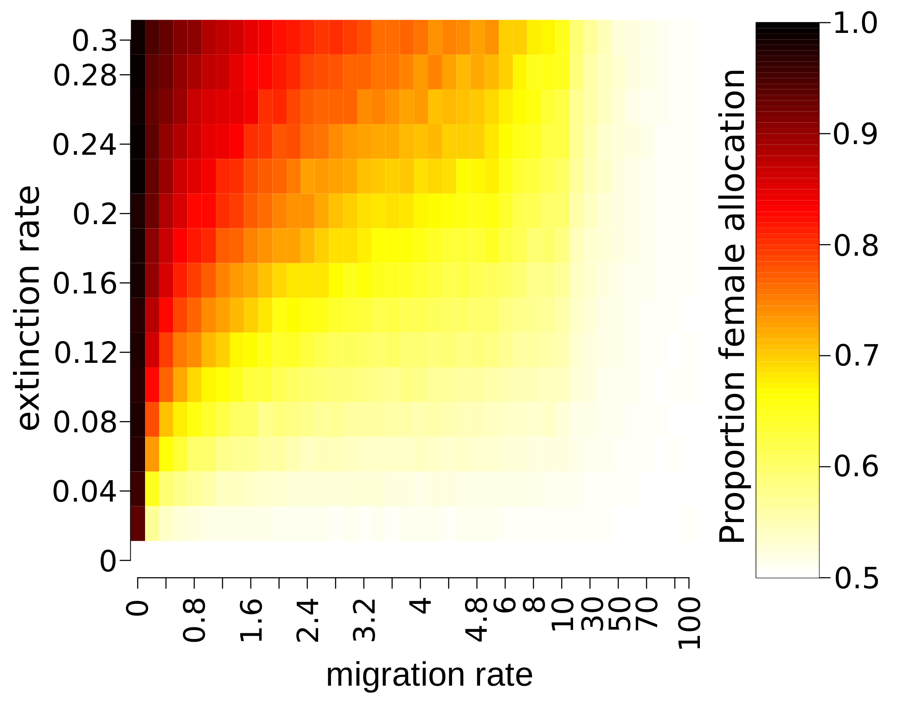

**Figure 1: effect of migration and extinction rates on female allocation**

Migration rates are shown along the x-axis.

Extinction rates are shown along the y-axis.

Colours show the average female allocation measured over the metapopulation at the end of simulations, in a scale lying from 0.5 (white: 50% of female allocation) to 1 (black: 100% of female allocation).

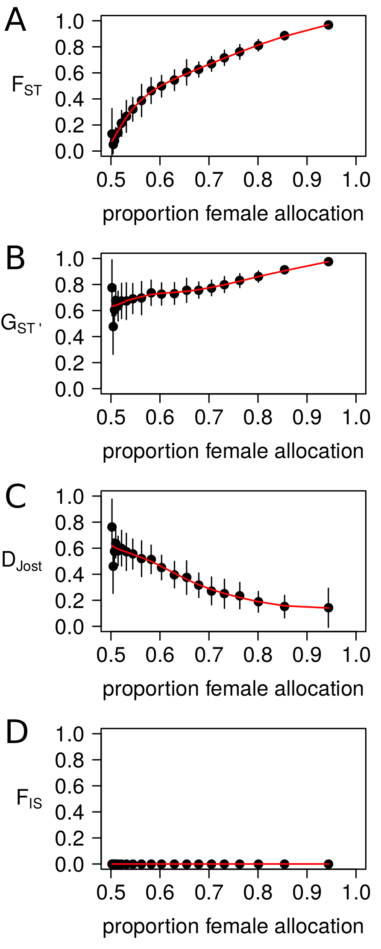

**Figure 2: relations between female allocation and descriptive statistics in population genetics at neutral markers.**

The x-axis shows the measured female allocation at the end of simulations described in figure 1-A.

The y-axis show; FST (**A**), GST' (**B**), Jost's *D* (**C**) and FIS (**D**).  
Each points represent a 5% quantile of the female allocation along the x-axis, and the mean descriptive statistics within each 5% quantile along th e y-axis. Vertical bars represent the standard deviation of the descriptive statistics within each 5% quantile.

The red line represents the loess regression between female allocation and descriptive statistics.

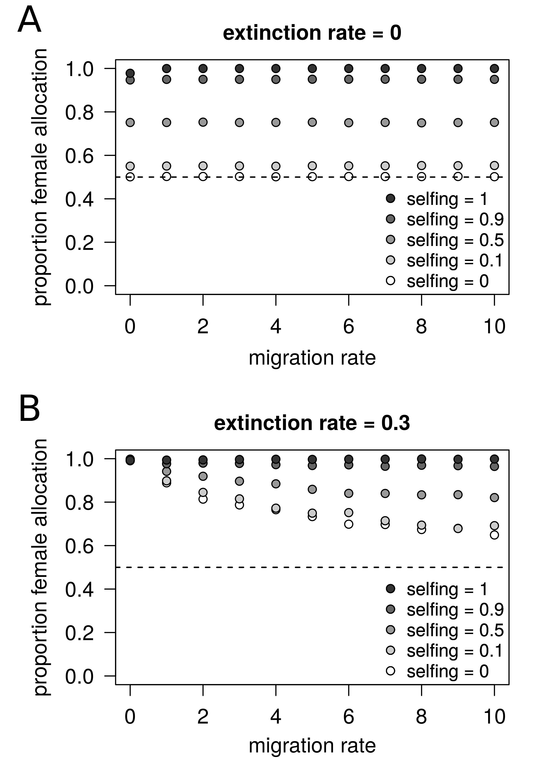

**Figure 3: female allocation in a metapopulation as a function of the migration rate and the base selfing rate of individuals**

The x-axis represent the immigration rates expressed as the mean percentage of individuals coming from random demes in the metapopulation per generation.

The y-axis represent the measured female allocation at the end of simulations.

Dots are represent the average over three independent replicates. Variation over replicates was very small, so that error bars are not shown.

The selfing rate here is the probability for an ovule to be fertilized by a male gamete coming from the same hermaphroditic individual prior to random mating; the realised selfing rate could thus be higher, depending on the population size. Four values of selfing were explored from 0 (white) to 1 (black).

Female allocation is shown when extinction rates are fixed to 0 (panel A) and 0.3 (panel B).

Dashed horizontal line shows female allocation of 50%.

**Supplementary information**

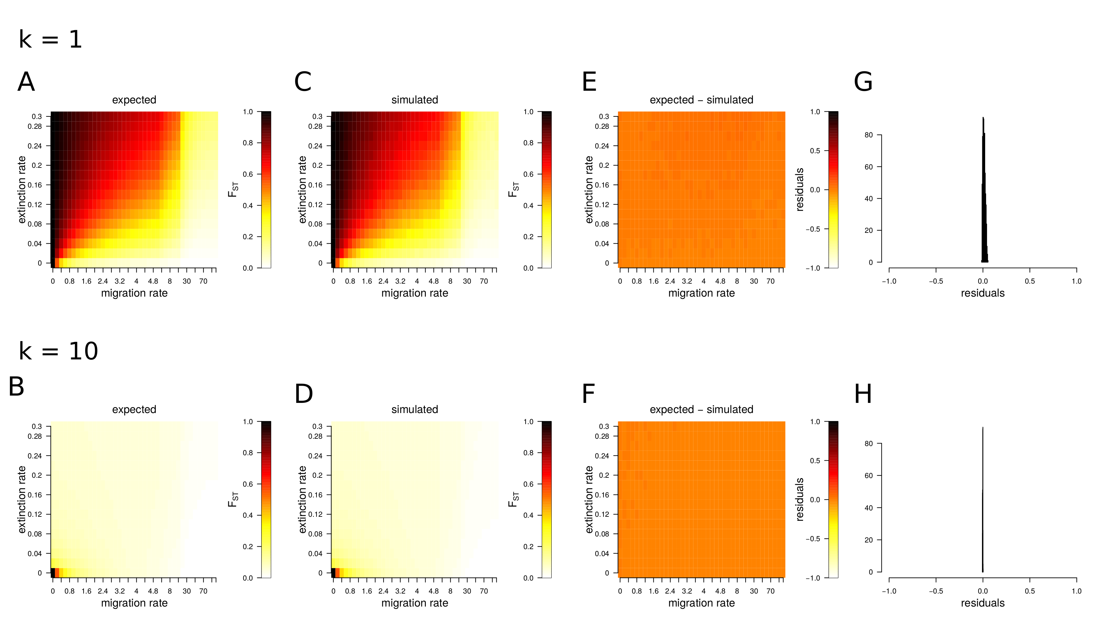

**Figure S1: ability of simulations to produce expected FST values.**

The migration rate is expressed as the mean percentage of individuals coming from random demes in the metapopulation per generation.

The extinction rate is expressed as the mean probability for a deme to become extinct and recolonized per generation.

Here, the number of colonizers is fixed to k = 1.

**A, B.** Analytical expectations following Rousset (2003) for FST as a function migration and extinction. Colours represent FST values lying from 0 (white) to 1 (black).

**C, D.** FST measured at 20 simulated neutral markers after 3,000 generations. 640 grid points were explored with combination of parameters similar to Fig. S1-A. Colours represent FST values lying from 0 (white) to 1 (black).

**E, F.** Residuals are the differences between expected (Fig. S1-A) and simulated (Fig. S1-B) values of FST for all combination extinction and migration rates. Colours represent possible values of residuals (= FST-Expected – FST-Simulated), putatively lying from -1 (white) to 1 (black).

**G, H.** Distributions of residuals over 1,920 simulations (640 combinations of parameters replicated three times).

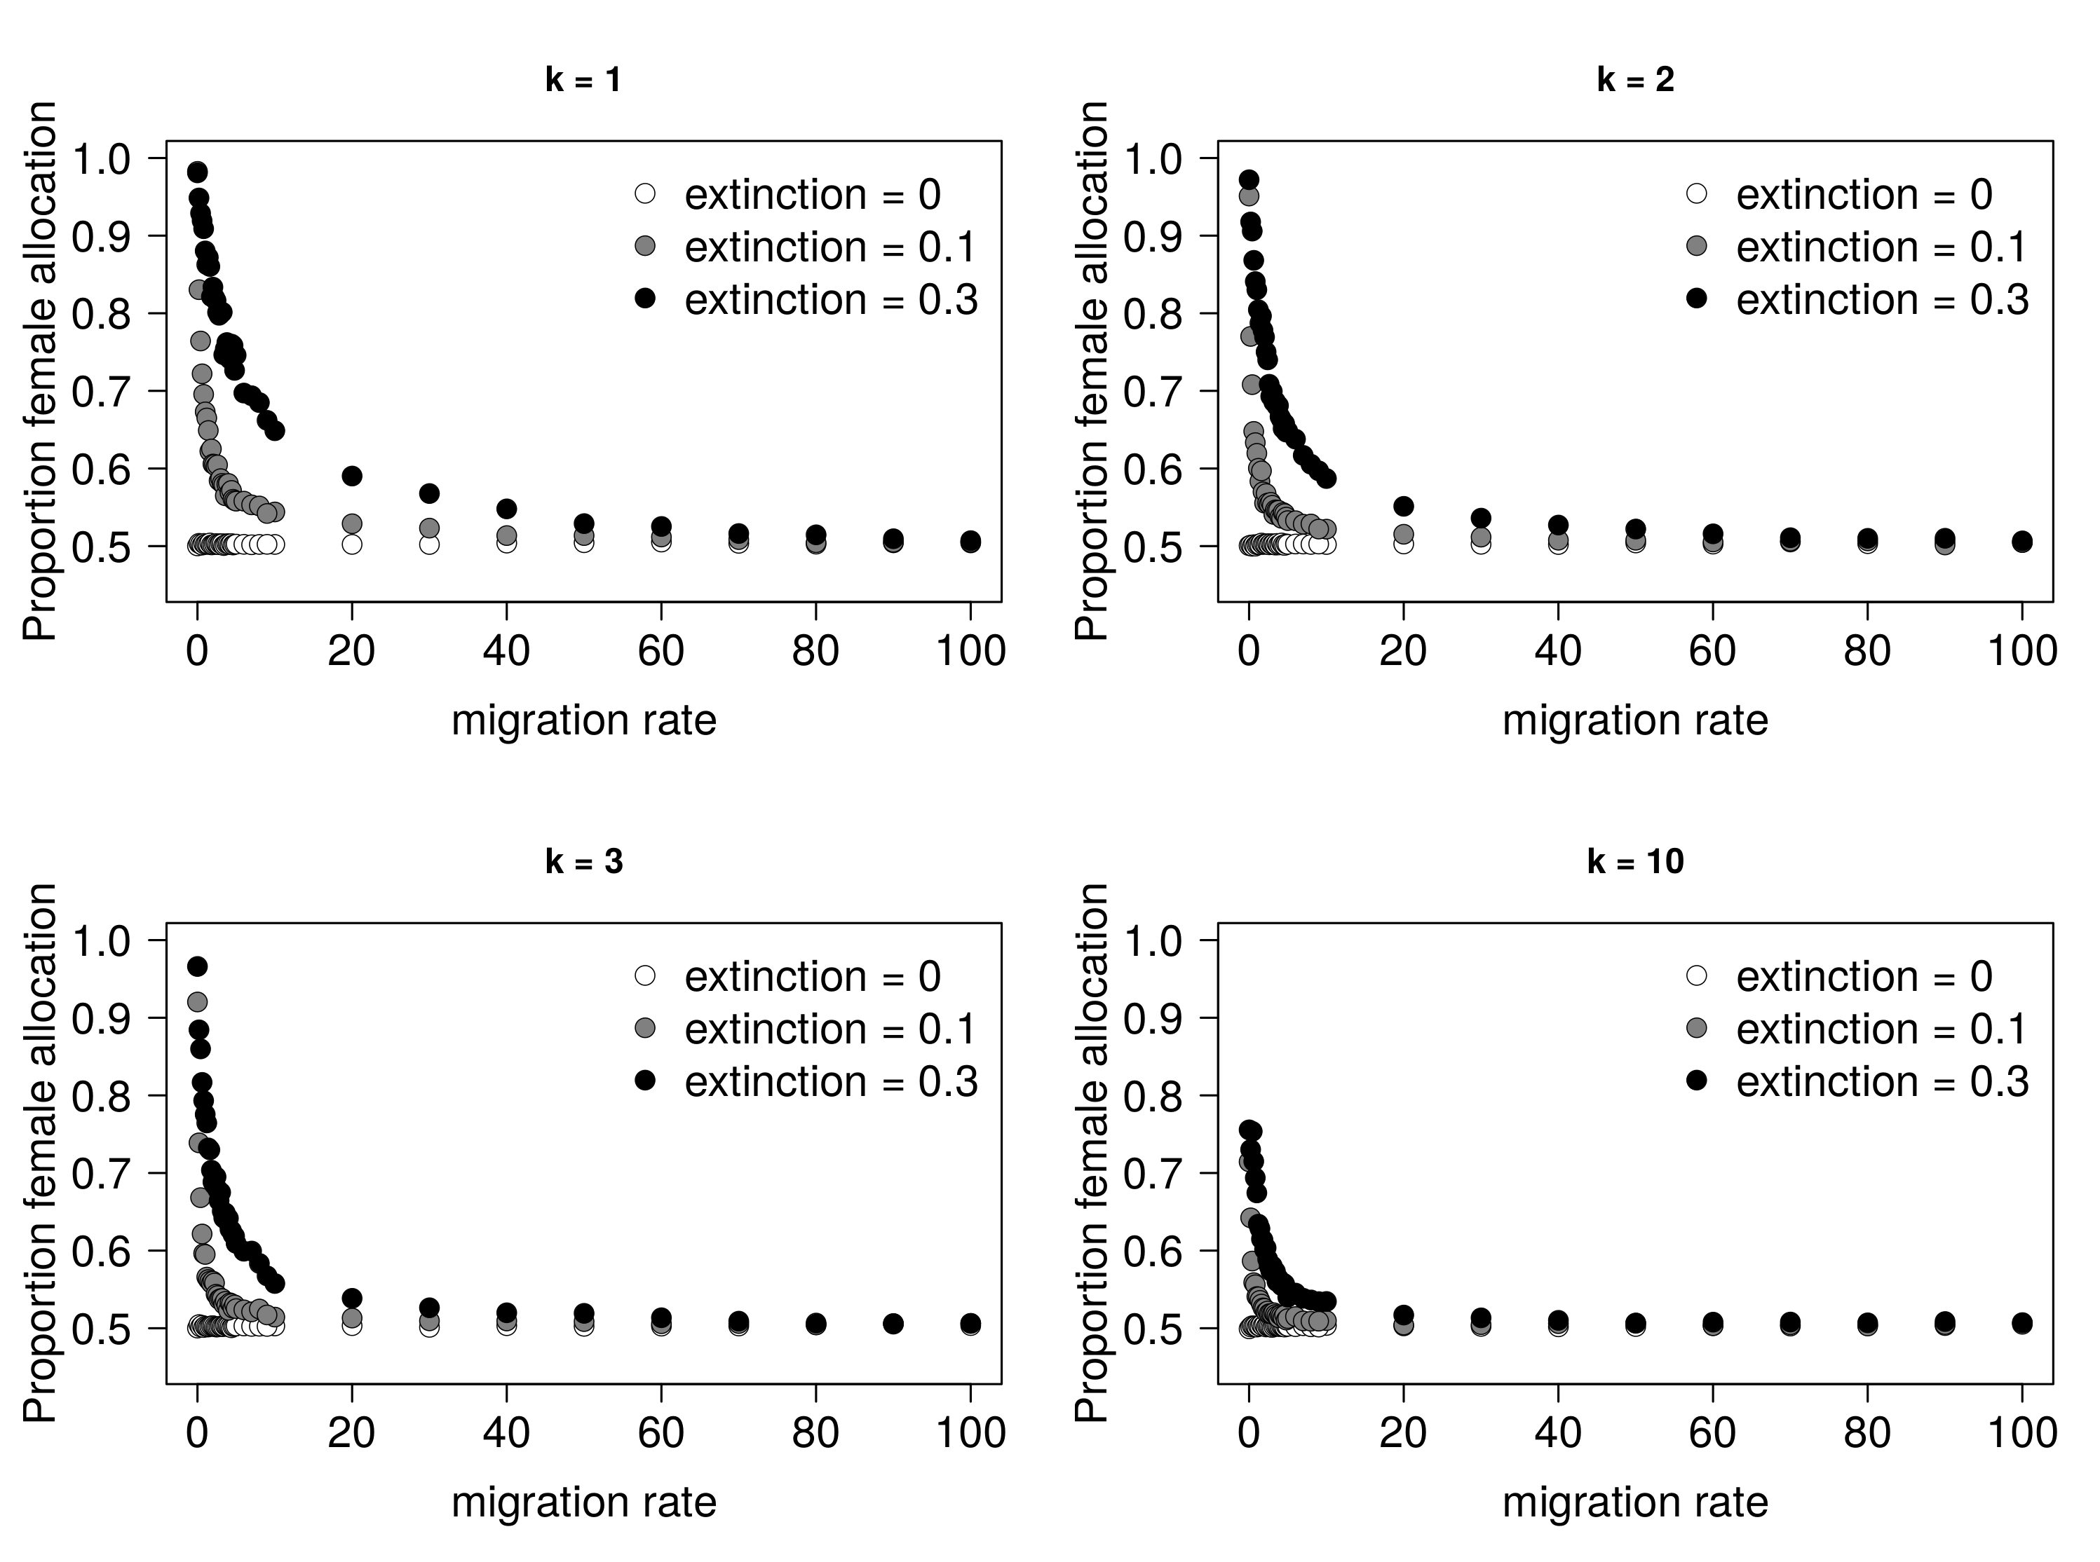

**Figure S2: effect of migration rate and extinction rate on female allocation.**

Results are shown for k=1, k=2, k=3 and k=10 colonizers making the propagule pool.

**Figure S3: relations between statistics in population genetics at neutral markers and female allocation for different selfing rates.**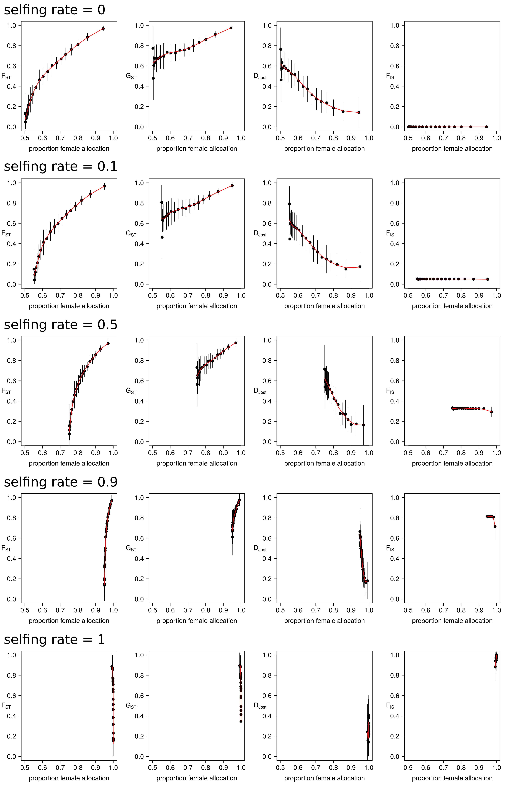

For each individual graphic window, the x-axis shows the measured female allocation at the end of simulations.

The y-axis show FST, GST' , Jost's *D* and FIS.

Five different selfing rates were explored:

First row of plots: selfing = 0.

Second row of plots: selfing = 0.1

Third row of plots: selfing = 0.5

Fourth row of plots: selfing = 0.9

Fifth row of plots: selfing = 1

Each points represent a 5% quantile of the female allocation along the x-axis, and the averaged descriptive statistics within each 5% quantile along the y-axis. Vertical bars represent the standard deviation of the descriptive statistics within each 5% quantile.

The red line represents the loess regression between female allocation and descriptive statistics.

**Figure S4: relation between migration rate and 7 statistics in population genetics at neutral markers for k = 1 colonizer**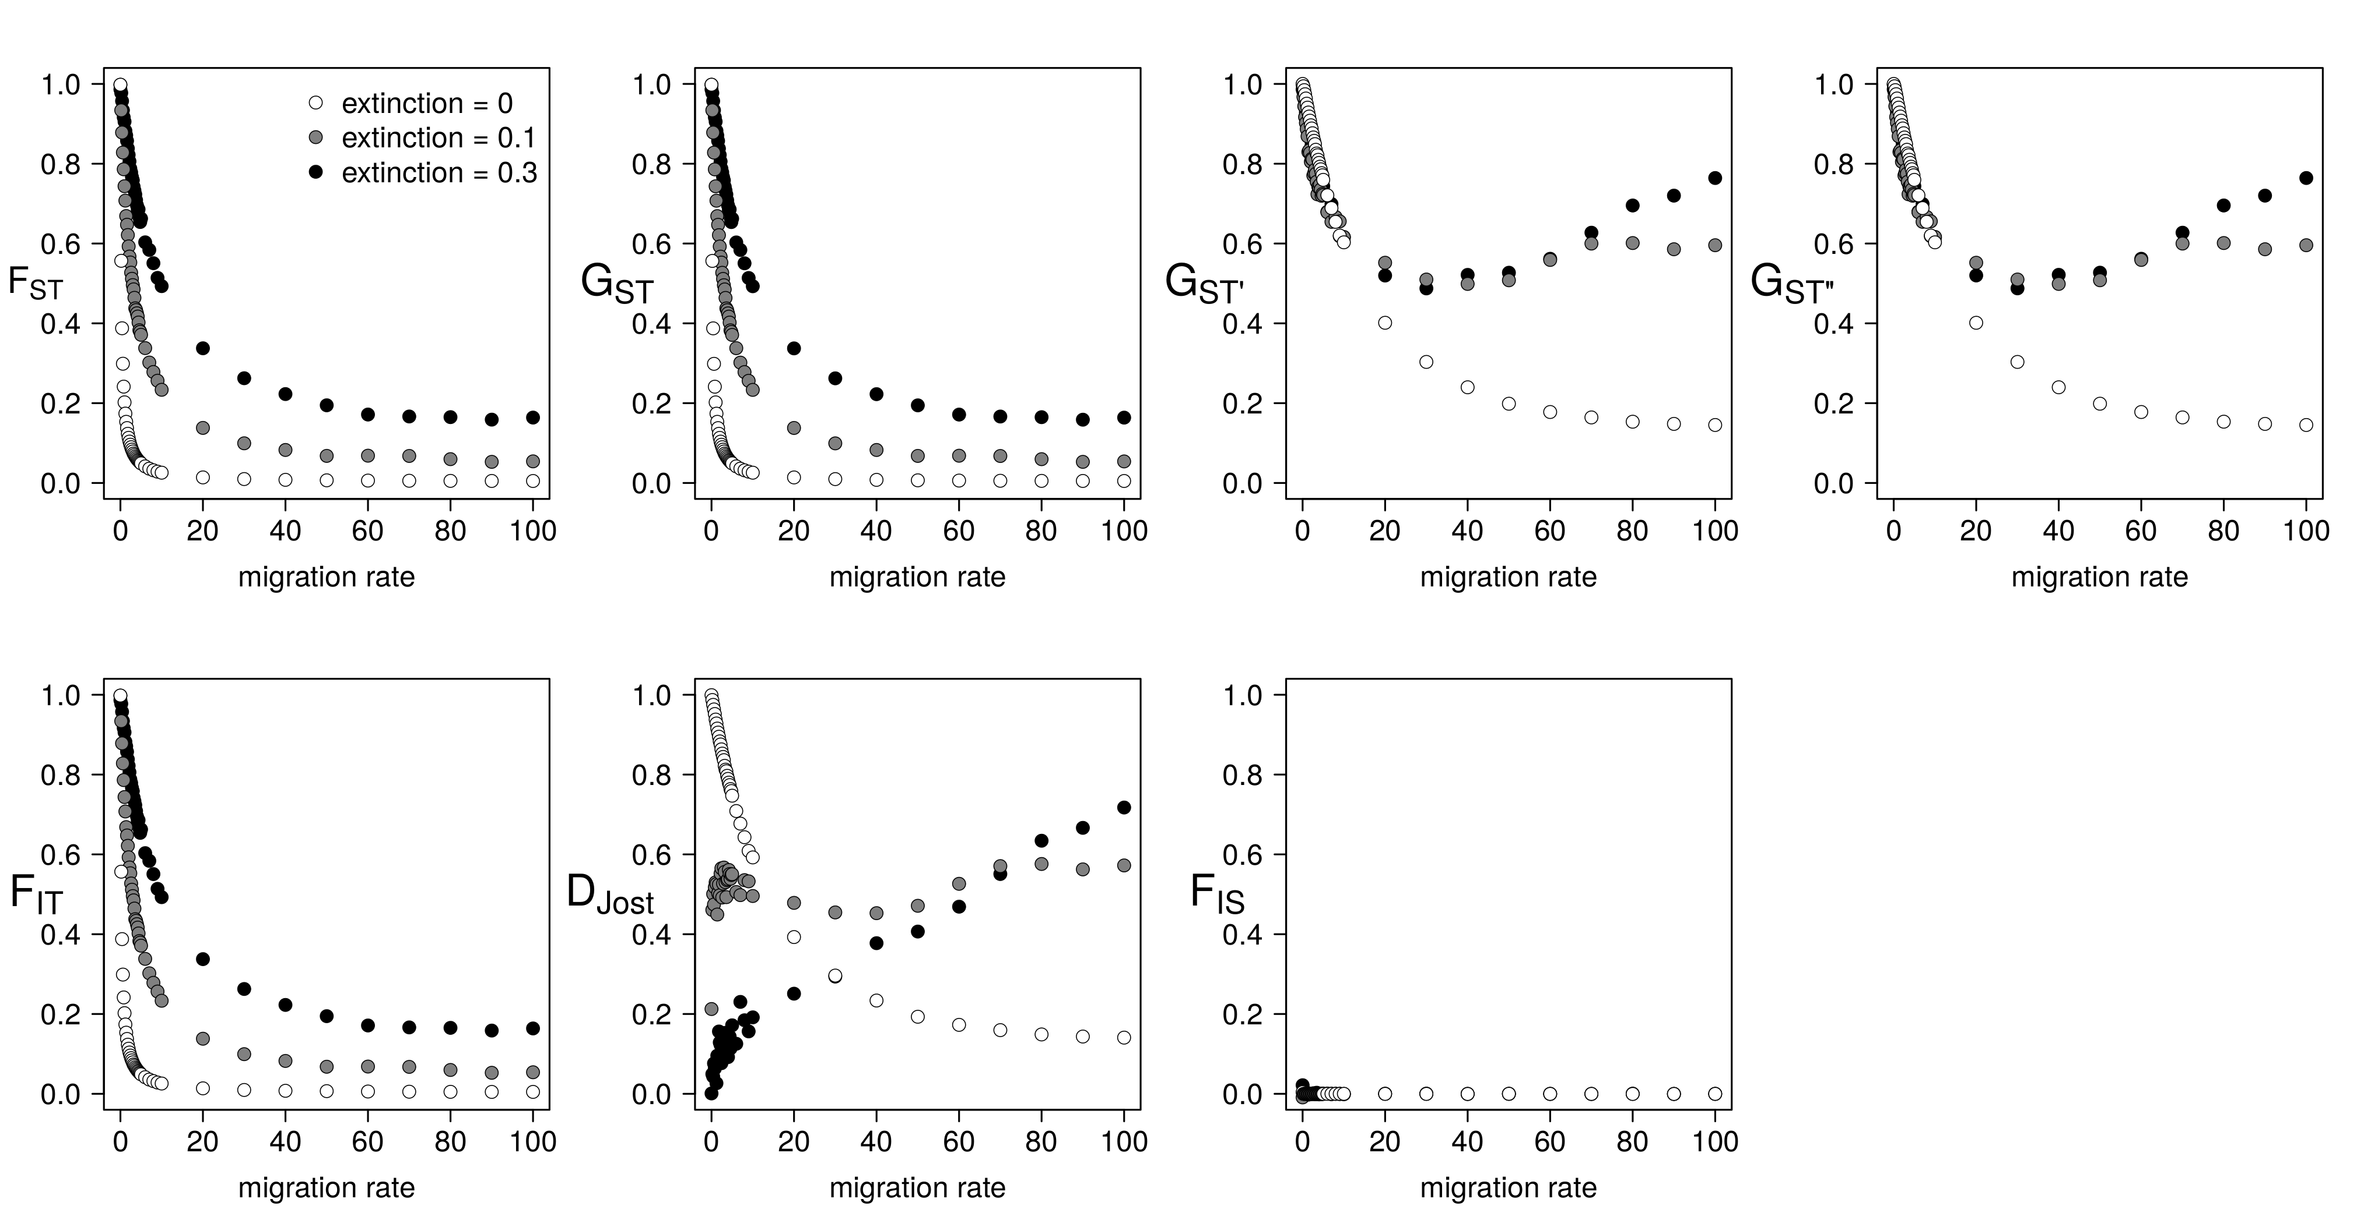

**Figure S5: relation between migration rate and 7 statistics in population genetics at neutral markers for k = 10 colonizers**